Times table handout
Online resources
https://play.ttrockstars.com/ – all children have their own login
https://www.topmarks.co.uk/maths-games/hit-the-button Hit the button
https://mathsframe.co.uk/en/resources/resource/477/Multiplication-Tables-Check Maths Frame Multiplication Check

Games and strategies
Fact of the day/week
Choose a fact per day/per week to constantly rehearse at home. You could put it on post it notes around the house, as lunchbox notes, practice it in the car… The possibilities are endless! Make sure you practice the question both ways round, for example 4 x 2 = 8 and 2 x 4 = 8.

Complete a times table grid
Go through the grid and fill in all the times table facts that your child knows already; this will help you to target the ones that still need more work. Once this is done, fill in the rest in a different colour and put it up somewhere in the house as a constant reminder.

Times table tricks
When first learning a new times table, there can be tricks to help.
The 9 times table is a great example of this – where you can use your hands to work out the answers.
Start by spreading all 10 fingers in front of you. To figure out 9×1, put your left pinky down. What are you left with? 9 fingers! For 9×2 put your left ring-finger down. What are you left with? 1 finger and a gap followed by 8 fingers or 18. This trick works up to 9×9 (8 and 1 or 81).

Stage a multiplication war!
This game is simple, two players draw a card from a deck. They then flip their cards over and the first person to correctly answer the total of the two cards multiplied together gets to put the cards in their winning pile. For example, if a 3 of hearts and a 7 of diamonds are flipped over, the first person who says 21 gets to keep the two cards. The person with the most cards in their winning pile at the end of the game wins.

Make a multiplication flower
Another one for displaying in the house, is to create a multiplication flower. Children start this activity by drawing the centre of the flower, in which they write a number between 2 and 12. They then draw 12 petals around the centre, with each petal containing the numbers 1 through 12. The last step is to draw another set of 12 petals which contain the centre number multiplied by each petal in the inner circle.
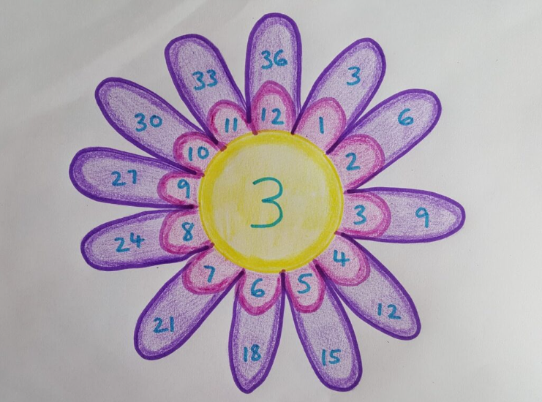
Rock, Paper, Times tables!
A different spin on Rock, Paper, Scissors. You count in as normal, but when you would normally show your rock, paper or scissors, you hold up a number of fingers between 1 and 10. The first to multiply both numbers together wins.
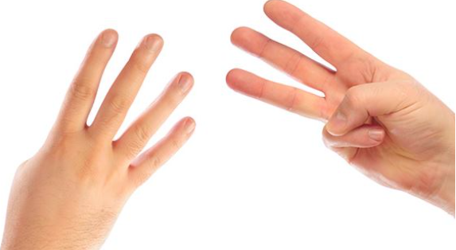
Sing!
There are loads of free times table songs on platforms such as YouTube. Music is proven to be a good way of remembering things – how many of you know all the words to your favourite songs from your teenage years?!

