A prayer space at home (adapted by Jill and Mike from ideas from Holland House)
You might like to create your own prayer space in your home over the next few weeks. It's a joyful thing to do and encourages hope and gratitude while you build it and spend time in it.
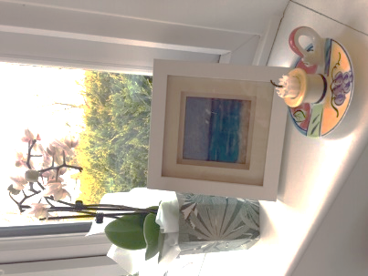
Here are some tips;
1) Size doesn't matter.... It can be a small table, a chair, a box, a windowsill, the corner of a large table etc
2) Build it in a place where you can be quiet, even if only for a short time. You only need quiet for maybe 10 minutes in one sitting.
3) Keep the space for the activity of prayer only - i.e. try not to let it get cluttered with cups, toys, pens etc
4) Put three things in the space
a) something that represents your faith / God / the Divine. This doesn't have to be the usual symbols such as a crucifix, cross, icon etc (but it certainly can if that's meaningful to you). It can be anything that speaks to you of Love.
b) a light – most religious traditions see light as showing the presence of God. If you have not got a battery tea light, you might want to make a candle out of card.
c) something that needs looking after - either a small indoor plant, a flower or a shallow dish of water (which quickly evaporates). This little being (whatever it is) will help draw you to the space. will call to you when its nearly gone, or indeed when it's finished, and you can give thanks for it and change it.

5) Make sure you can sit comfortably and ready in the space to think quietly about God’s Love. Even though we are always in the presence of God’s Love, sometimes we forget, or feel separated from it, and so we need some help. So go sit quietly in the space – be sad if you want to, smile if you want to, close your eyes and feel your breath going in and out, open your eyes and gaze at your symbols - each is a reminder of the everlasting presence of God’s Love.

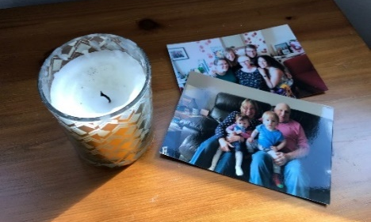
Try to visit the space regularly, at least once a day - if only for a few minutes. Indeed, if you're very busy with something else, just stand next to your space quietly looking at your symbols - letting them be a reminder that you're loved, and then get on with your day.
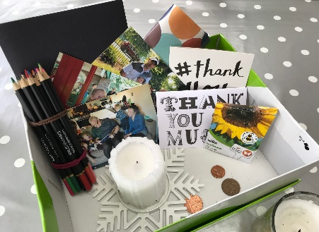
Alternatively, if you can’t leave a prayer place up all the time you could keep some things in a box and just get them out when you want to use them.

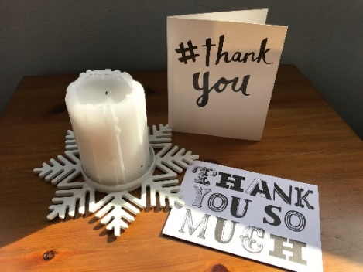
Photos of loved ones might guide your prayers for them. Holding coins might help to you to pray for the Queen and the government at this time. You could write prayers of thanks in Thank You cards. Planting seeds together could help you to pray for growth in new areas, or you might use a drawing pad to draw your prayers instead. You might find other items around your house that help you to pray in your own way.

